**Modeling Epidemic Dynamics: An Agent-Based Simulation Approach**

**Sree Sarada Alapaty**

G01440615

HAP 774

George Mason University

**Abstract**: Infectious disease modeling has emerged as an essential instrument for comprehending epidemic dynamics and guiding public health measures. This project introduces an interactive agent-based simulation model aimed at examining the dissemination of an epidemic throughout a diverse community. The model integrates essential public health treatments, including vaccination and social distance, enabling users to examine their impacts on epidemic outcomes via adjustable parameters.  
  
Agents, representing persons, demonstrate realistic behaviors like movement, interaction, and compliance with interventions, while progressing through various health states: Susceptible, Infected, Recovered, and Vaccinated. The model utilizes the Mesa framework for agent-based modeling and incorporates dynamic visualizations facilitated by Plotly, which emphasize significant trends and milestones, such peak infection and the initiation of vaccinations.  
  
Results indicate the nonlinear impacts of interventions, illustrating that early vaccination efforts and high adherence to social distance can substantially mitigate the epidemic's impact. This project is both instructional and analytical, allowing users to play with different scenarios and see real-time outcomes on an accessible, interactive platform. The simulation highlights the significance of prompt and targeted public health interventions, connecting theoretical models with practical implementations.  
  
This project has potential for further improvement, including the integration of real-world data, the incorporation of more intricate agent behaviors, and the customization of the model for specific diseases such as COVID-19 or influenza, rendering it a versatile tool for epidemiological research and decision-making.

**Introduction**: Epidemics are a major public health concern worldwide, necessitating prompt and efficient measures to lessen their impact and spread. The ability to simulate and forecast epidemic dynamics is crucial for public health policies and outbreak preparation. By simulating the interactions of individual agents, each representing a population entity with unique characteristics and behaviors, agent-based modeling (ABM) can examine epidemic behavior.  
  
This project provides an epidemic simulation model using Mesa for agent-based modeling, interactive widgets, and Plotly for dynamic visualizations. The model mimics infectious disease propagation in a diverse population, including agent movement, interactions, and state changes. It lets users alter infection incidence, recovery rate, compliance levels, and vaccine scheduling to examine various scenarios, including vaccination campaigns and social distancing.  
  
Age groups, intervention adherence, and probabilistic transitions between health states—Susceptible, Infected, Recovered, and Vaccinated—are realistic in the simulation. These qualities allow the model to simulate epidemic dynamics, revealing how public health initiatives affect illness outcomes.  
  
Users can track epidemic milestones like peak infection rates and vaccination rollouts using interactive infographics. This project teaches epidemic modeling and lays the groundwork for public health planning research by providing a simple and adaptable platform.  
  
This study describes the model's design, parameters, and results, showing its capacity to mimic epidemics. It finishes with ways to make the model more applicable to real-world epidemics and useful for public health interventions.

**Objectives:** The primary objectives of this epidemic simulation project are:

1. Model Epidemic Dynamics:  
   Simulate the spread of an infectious disease within a population using an agent-based modeling approach to understand the underlying dynamics of epidemics.
2. Evaluate Public Health Strategies:  
   Analyze the effectiveness of interventions such as vaccination campaigns, social distancing, and compliance rates on controlling the spread of the disease.
3. Enable Parameter Exploration:  
   Provide an interactive platform for users to adjust key parameters, such as infection and recovery rates, to explore various epidemic scenarios and outcomes.
4. Visualize Real-Time Epidemic Progression:  
   Use dynamic visualizations to present epidemic trends over time, highlighting milestones such as peak infections and the impact of vaccination rollouts.
5. Education and Inform Policy Decisions:  
   Serve as a learning tool for public health professionals, educators, and researchers by offering insights into epidemic control strategies through simulations.
6. Provide a Scalable Foundation for Research:  
   Develop a modular and extensible simulation framework that can be enhanced to incorporate additional complexities, such as varying population densities or age-specific disease progression.

**Methodology**: This project employs an agent-based modeling (ABM) approach to simulate the spread of an epidemic in a population. The methodology combines dynamic agent behavior, environmental interactions, and data visualization to analyze various epidemic scenarios. The following subsections describe the model's design, agent dynamics, implementation, and visualization in detail.

1. Model Design

The epidemic simulation is structured using the Mesa framework, which provides tools for agent-based modeling. Key components include:

* Agents (Persons):  
  Each individual in the population is modeled as an agent with attributes such as age group, health status, and vaccination status. Agents interact with their environment and each other to simulate disease progression.
* Environment (Grid):  
  The environment is a 2D toroidal grid where agents move and interact. The grid facilitates the spatial simulation of disease transmission.
* Simulation Parameters:
* Population Size (N): Total number of agents.
* Infection Rate: Probability of disease transmission upon contact.
* Recovery Rate: Probability of recovery for infected agents.
* Compliance Rate: Degree of adherence to social distancing.
* Vaccination Start Day: Day when vaccination begins in the simulation.
* Vaccine Efficacy: Effectiveness of the vaccine in preventing infection.

2. Agent Dynamics

Each agent represents a person with the following attributes and behaviors:

Attributes:

state: The current health status (Susceptible, Infected, Recovered, or Vaccinated).

is_vaccinated: Boolean indicating if the agent is vaccinated.

age_group: Categorized into young, adult, and elderly for differential prioritization during vaccination.

Behaviors:

* Movement: Agents move within the grid unless restricted by social distancing or compliance constraints. Movement is probabilistic to simulate real-world variability.
* Disease Progression: Susceptible agents may become infected upon contact with an infected neighbor, based on the infection rate. Infected agents recover probabilistically, based on the recovery rate.
* Contact: Infected agents can transmit the disease to neighbors who are susceptible.

3. Vaccination Strategy

The model incorporates a vaccination strategy that begins on a specified day:

* Prioritization: Vaccination is prioritized for specific age groups, with elderly agents receiving higher priority.
* Daily Vaccination Limit: Only a limited number of agents can be vaccinated each day.
* Vaccination Efficacy: Vaccination reduces the likelihood of infection, based on vaccine efficacy.

4. Simulation Flow

* Initialization: Create a population of agents distributed randomly on the grid.
* Assign initial states, including a small subset of Infected agents to seed the epidemic.
* Daily Steps: Each agent performs its step function, which includes movement, contact, and disease progression.
* Vaccination is administered to eligible agents based on the defined strategy.
* Data Collection: Key metrics (Susceptible, Infected, Recovered, Vaccinated) are collected at each step using Mesa's DataCollector.
* Termination: The simulation runs for a fixed number of days (e.g., 100) or until no agents remain in the Infected state.

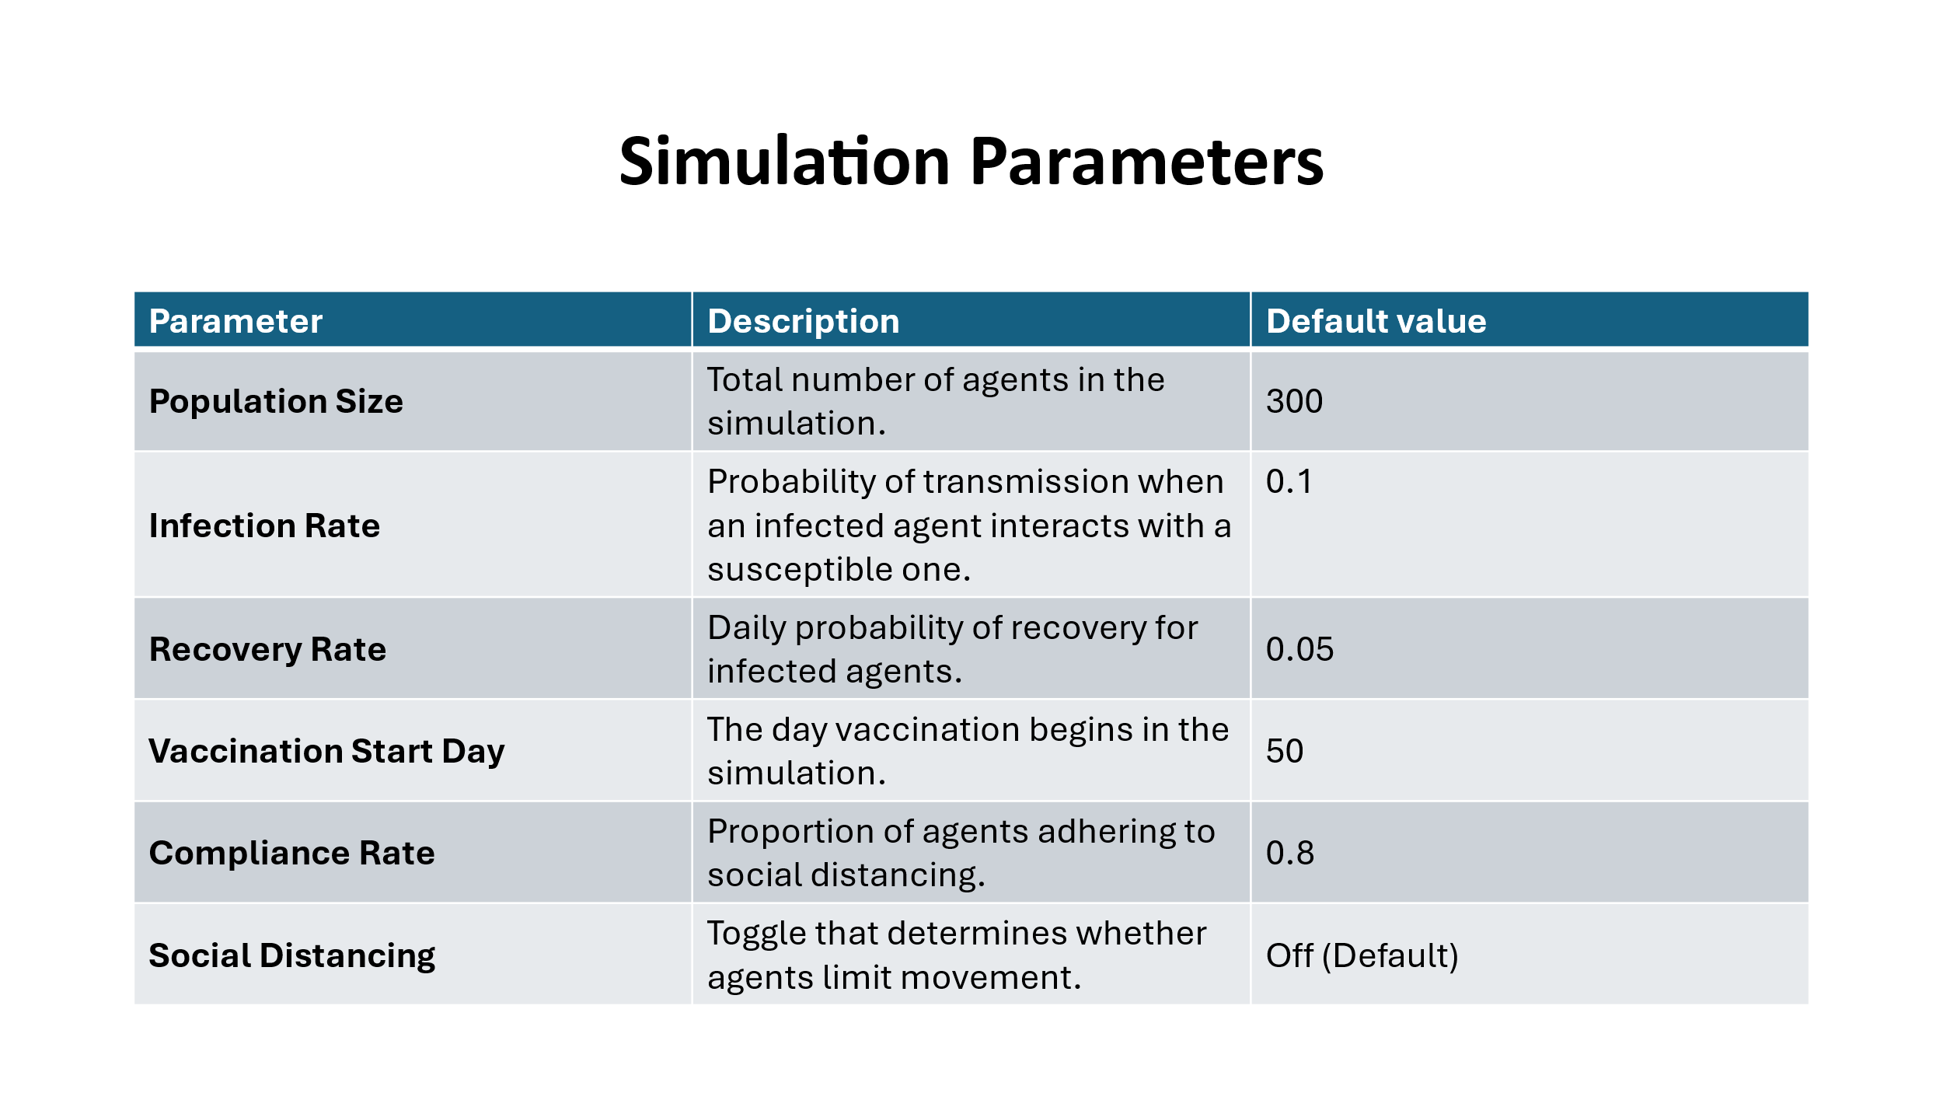

5. Visualization

The results are visualized using Plotly to provide an interactive and dynamic representation of the epidemic's progression:

* Line Graphs:  
  Display the number of agents in each state (Susceptible, Infected, Recovered, Vaccinated) over time.
* Annotations:  
  Key events, such as peak infections and the start of vaccination, are highlighted for better understanding.
* Interactive Widgets:  
  Parameters such as population size, infection rate, recovery rate, compliance, and vaccination start day can be adjusted using IPyWidgets, allowing users to explore various scenarios in real-time.

6. Code Implementation

The simulation is implemented in Python, leveraging:

Mesa Framework: For agent-based modeling and simulation design.

Plotly: For interactive visualizations.

IPyWidgets: For user interaction and parameter control.

**Results & Analysis:**

Visualization Overview  
The simulation results are displayed as a live graph illustrating the epidemic's progression over a period of 100 days. The graph monitors four principal agent states:

* Susceptible (Blue): Population remains vulnerable to infection.
* Infected (Red): Individuals presently infected and able to transmit disease.
* Recovered (Green): Individuals who have acquired immunity following recovery.
* Vaccinated (Yellow): Individuals who have received immunization via vaccine procedures.

This visual depiction offers an in-depth comprehension of the interaction among different phases as the epidemic progresses, emphasizing significant milestones and the effects of interventions.

**Key Insights:**

* Peak Infection: The epidemic peaks on Day 27, with 133 people concurrently affected. This represents the point of maximal transmission within the population, which is highlighted on the graph for clarity.
* Impact of Vaccination:  
  Vaccination interventions begin on Day 50, clearly indicated by a vertical dashed line. Following this, a drop in the susceptible and infected populations is correlated with a steady increase in the vaccinated population (yellow curve).  
  The effect of vaccination becomes increasingly evident in the latter portion of the simulation, as it markedly decreases illness transmission.
* Susceptible Population Decline: The susceptible population (blue curve) experiences a rapid decline in the initial stages of the epidemic as individuals transition to infected or recovered states. This decline is furthered after vaccination.
* Dynamics of Recovery Curves: The quantity of recovered people (green curve) rises consistently as the diseased population starts to recover. Natural immunity evolves gradually over time, as evidenced by this dynamic.
* Trade-offs in Intervention: Moderate social distancing compliance (69%) delays the peak but does not prevent widespread transmission prior to immunization.  
  Due to delayed vaccination (Day 50), the outbreak can reach its peak before it can be significantly reduced.

Parameter Influence  
The simulation highlights the essential significance of pivotal parameters:

* The infection rate of 0.26 significantly contributed to the swift increase in infections, resulting in an early peak.
* The low recovery rate of 0.05 prolonged the duration of the infected population, hence delaying the shift to restored immunity.
* Vaccination Initiation on Day 50: Postponing vaccination until Day 50 let the infection to proliferate uncontrollably for almost half of the simulated duration.
* Social Distancing Compliance (0.69): Partial adherence lowered the infection rate but did not effectively prevent the epidemic's peak.

**Insights and Consequences**:

* Timing of Intervention: The prompt initiation of vaccination initiatives or enhanced adherence to social distancing measures could markedly diminish peak infection rates and avert the strain on healthcare systems.
* Role of Vaccination: Vaccination is essential for diminishing the susceptible population and averting further illness surges. Enhancing vaccination rates early in the outbreak expedites stability.
* Systemic Preparedness: The simulation underscores the necessity for integrated methods that encompass vaccination, social distance, and public health initiatives to successfully curtail the transmission of infectious diseases.

**Conclusion:**

This project effectively uses agent-based modeling to simulate the dynamics of an epidemic, offering important insights on how important variables like infection rates, recovery rates, vaccination strategies, and social distancing compliance interact. The model illustrates the impact of public health initiatives, including vaccination and social distance, on the progression of an epidemic.  
  
Important conclusions include:

* The peak infection rate and the overall number of infections are considerably decreased by early vaccine intervention and improved adherence to social distance.
* Delays in vaccination lengthen the epidemic's duration and raise the burden on the vulnerable population.
* To get the best results, the model highlights how crucial it is to combine vaccination programs with non-pharmaceutical therapies.

This simulation provides a versatile and interactive tool for studying the spread of infectious diseases, assessing preventive strategies, and making evidence-based decisions for public health planning.

**Future Work:**

* Real-World Data Integration: Enhance the model by using real epidemiological data, including age-specific illness rates, movement trends, and vaccination rates, to get more accurate simulations.
* Complex Agent Conduct: Incorporate varied agent behavior, including varying compliance levels, mobility patterns, and interaction rates influenced by demographic parameters such as age, occupation, and health status.
* Modeling the Temporal Efficacy of Vaccines: Model situations in which vaccine efficacy diminishes over time, indicating the necessity for booster doses or declining immunity.
* Multi-Strain Epidemics: Augment the model to incorporate the progression of different viral strains exhibiting diverse transmissibility and severity, reflecting real-world intricacies similar to COVID-19 variants.
* Limitations of the Healthcare System: Incorporate parameters to model healthcare system constraints, like hospital bed capacity and resource availability, to analyze their effects on epidemic outcomes.
* Economic and Social Consequences: Enhance the model to assess the socioeconomic effects of interventions, encompassing workforce disruptions, educational interruptions, and public compliance expenditures.
* Dashboard for Scenario Comparison: Create an intuitive dashboard that enables stakeholders to concurrently compare several intervention scenarios, hence enhancing informed decision-making.

This study establishes a foundation for advanced epidemic modeling tools that can assist policymakers in efficiently controlling future public health crises.

**References:**

1. **Anderson, R. M., & May, R. M.** (1991). *Infectious Diseases of Humans: Dynamics and Control.* Oxford University Press.
2. **Kermack, W. O., & McKendrick, A. G.** (1927). "A Contribution to the Mathematical Theory of Epidemics." *Proceedings of the Royal Society of London. Series A, Containing Papers of a Mathematical and Physical Character,* 115(772), 700–721.
3. **World Health Organization (WHO).** (2022). *Guidelines for Epidemic Preparedness and Response.* Retrieved from <https://www.who.int>
4. **Mesa Framework Documentation.** (2023). *Agent-Based Modeling in Python.* Retrieved from <https://mesa.readthedocs.io>
5. **Plotly Documentation.** (2023). *Interactive Data Visualization in Python.* Retrieved from <https://plotly.com/python>

.